Arrays
______________________________________________________________________
Array is a collection of similar type of data or it is used for store more than one values in single variable of same type.

How to use array in JAVA
_______________________________________________________________________
If you want to use array in JAVA we have two ways.

1. Declaration: declaration means we specify type of array not specify its size called as declaration
Syntax: datatype variablename[];
Example: int a[]; //declaration
2. Memory Allocation: Memory allocation means to decide how much memory required or set the size of array at program run time and if we want to allocate memory of array in java we have to use new keyword
Syntax: variablename = new datatype[size];
Example: a = new int[5];
Note: if we declare variable of array in java then we can say array variable known as reference variable
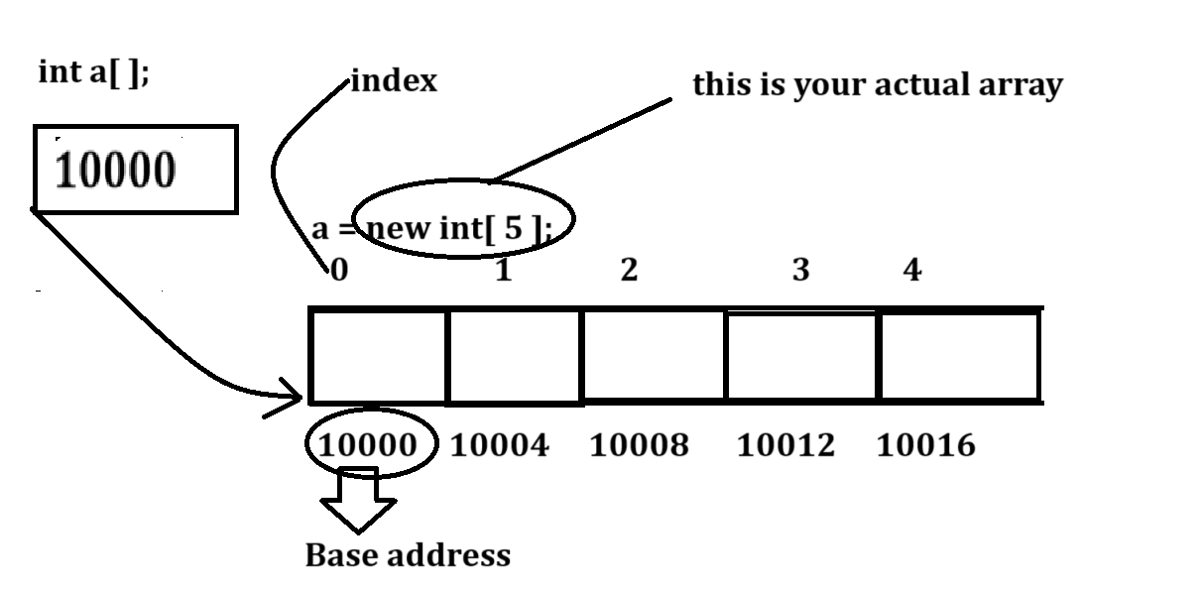
Note: if we think about above diagram we have variable int a[]; this is your reference variable because it contain base address of array and 0th location address called as base address.
If any variable in java is able to store the address of some memory known as reference or internally pointer.

How to store data in array
_________________________________________________________________________
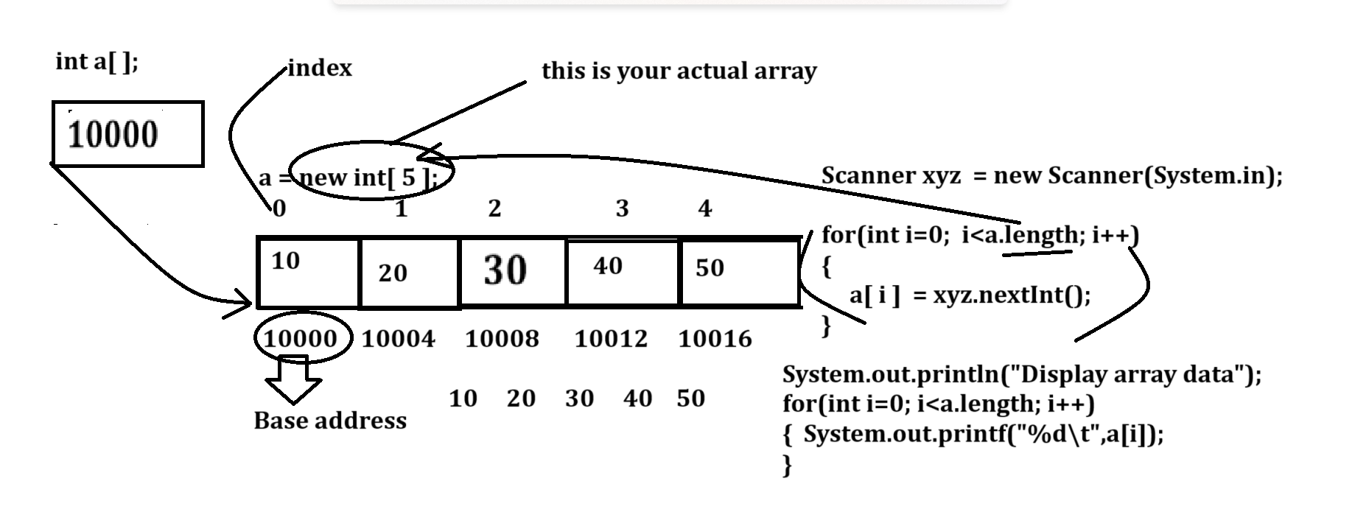

Example with source code
import java.util.*;
public class ArrDemoApp
{
public static void main(String x[])
{
Scanner xyz = new Scanner(System.in);
int a[]=new int[5];//array created
System.out.println("Enter five values in array");
for(int i=0; i<a.length; i++)
{ a[i]=xyz.nextInt();
}
System.out.println("Display array values");
for(int i=0; i<a.length; i++)
{ System.out.printf("%d\t",a[i]);
}
}
}

Example: WAP to input five values in array and calculate its sum
10 20 30 40 50 = 150
import java.util.*;
public class ArrDemoApp
{
public static void main(String x[])
{ int sum=0;
Scanner xyz = new Scanner(System.in);
int a[]=new int[5];//array created
System.out.println("Enter five values in array");
for(int i=0; i<a.length; i++)
{ a[i]=xyz.nextInt();
}
System.out.println("Display array values");
for(int i=0; i<a.length; i++)
{ System.out.printf("%d\t",a[i]);
sum = sum+a[i];
}
System.out.printf("\nSum of all value is %d\n",sum);
}
}

Example: WAP to Create Array of size 5 and find the maximum value from array.
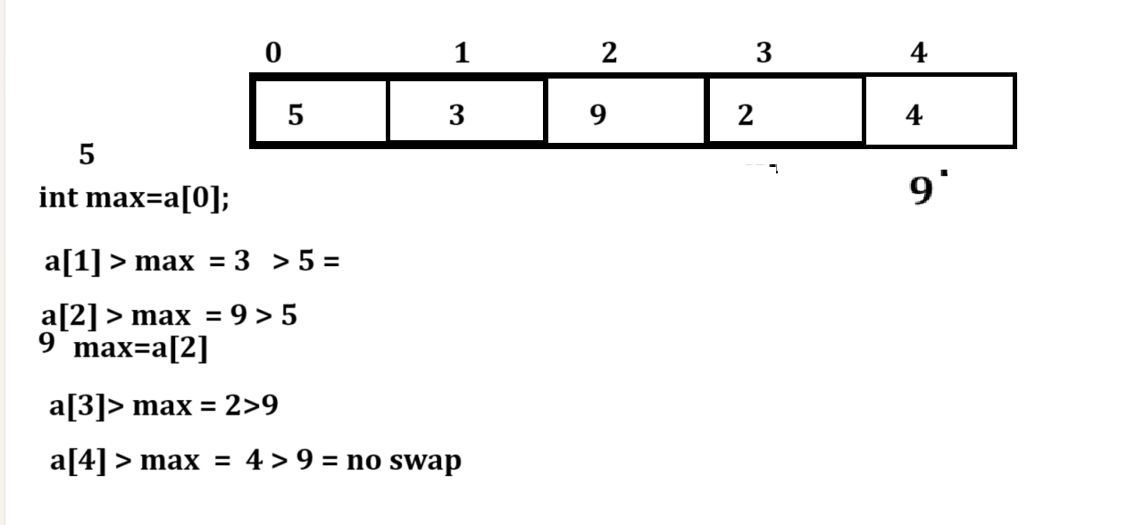
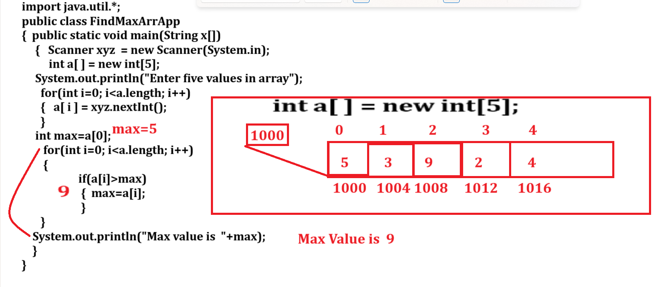

Example: WAP to input five values in array and input search value from keyboard and search value present in array or not
If we want to solve this problem we are going to use linear search technique
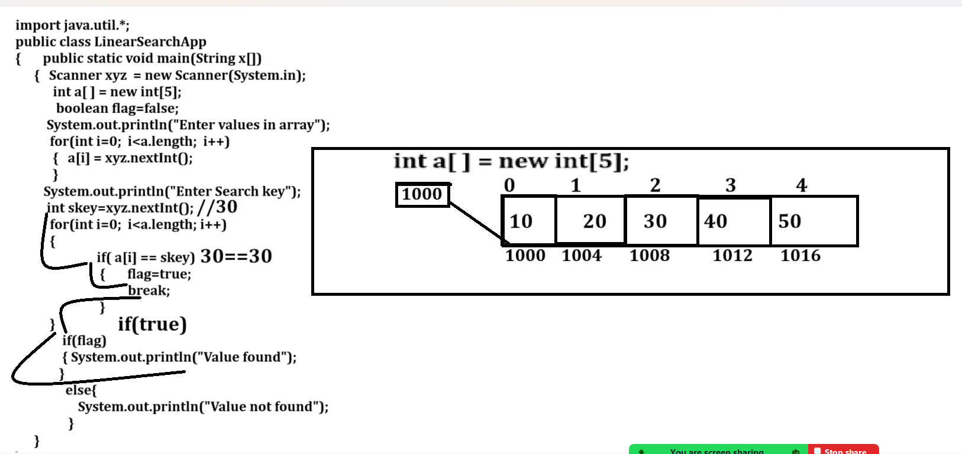

Example: what will be output of given code?
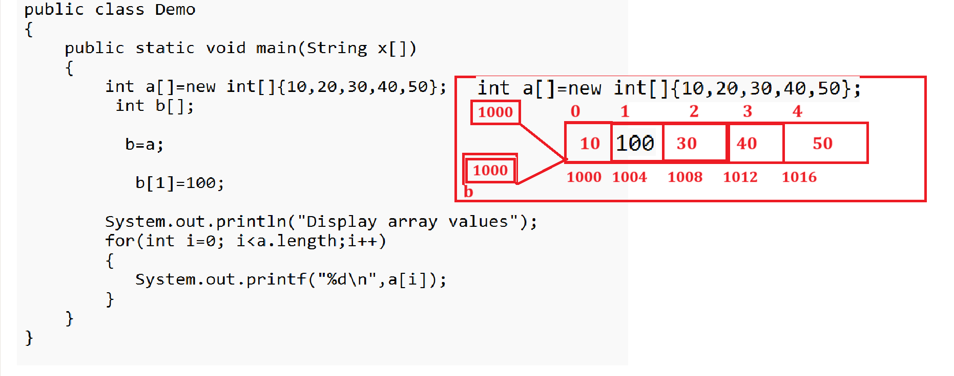

Note: if we think about above code we have statement int a[]=new int[]{10,20,30,40,50} here we create array memory and consider its base address is 1000 and we this address in reference variable a and we have another reference variable name as int b[] and we have statement b=a means we initialize address or base address of array in reference in b which is present in reference variable a means here b contain 1000 address it is base address of array means reference variable a and b points to same memory so when we have b[1]=100 means we insert the value on 1st index of array whose base address is 1000 in our diagram means here b[1]=a[1] so 100 get override on 20 so when we print the array then we get answer 10 100 30 40 50

Q. what will be output of given code
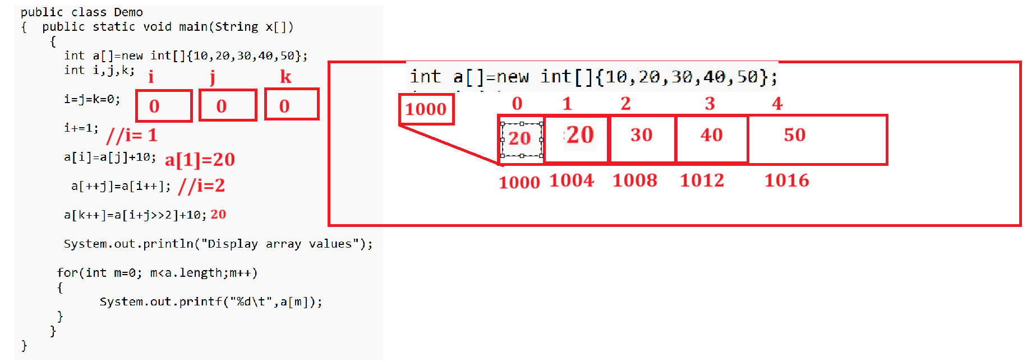

How to pass array as parameter to function
___________________________________________________________________________
If you want to pass array as parameter in function we need to pass base address of array in function.

Q. What is base address of array?
_________________________________________________________________________
0th location address called as base address of array from function calling point

Q. How to get base address of array?
____________________________________________________________________________
If we want to get base address of array we need to use array without subscript or array bracket.
Syntax: arrayname;
Example: int a[]=new int[]{10,20,30,40,50};
System.out.println(System.identityHashCode(a)); //base address

Example: WAP to create function name as void show(int a[]) so this function can accept array as parameter and can display value of array.
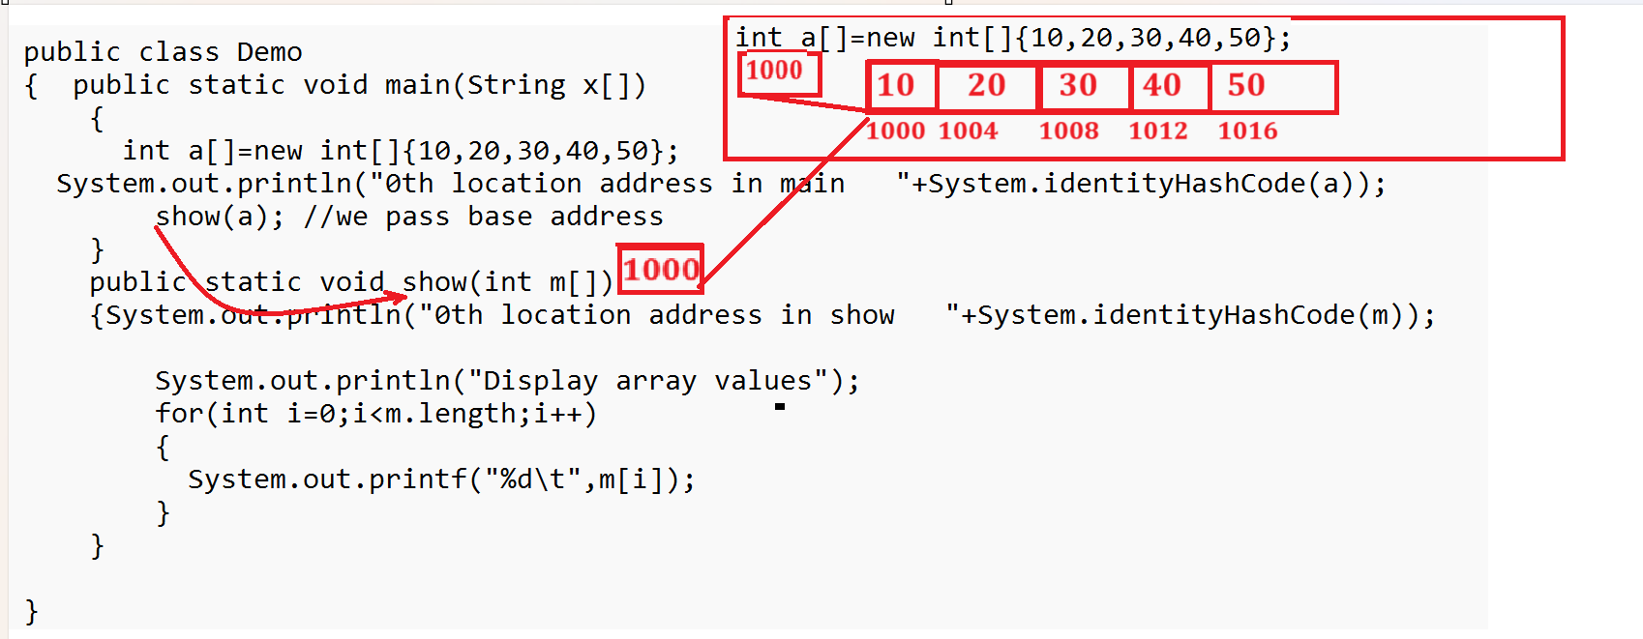

Example: WAP to create function name as int getSum(int a[]) this function can accept array as parameter and calculate the sum of all elements and return value from function.

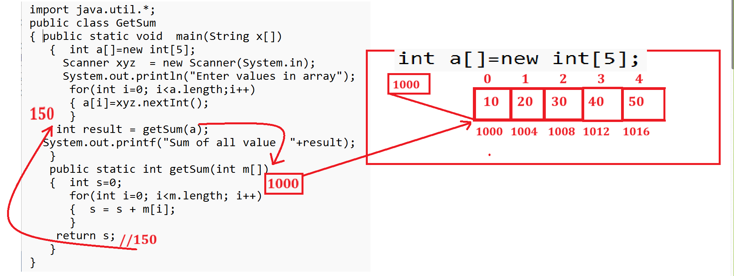

Example: What will be output of given code?
import java.util.*;
public class GetSum
{ public static void main(String x[])
{ int a[]=new int[5];//10 20 30 40 50
Scanner xyz = new Scanner(System.in);
System.out.println("Enter values in array");
for(int i=0; i<a.length;i++)
{ a[i]=xyz.nextInt();
}
calSum(a);
System.out.println("display array");
for(int i=0;i<a.length;i++)
{ System.out.printf("%d\t",a[i]);
}
}
public static void calSum(int m[])
{ m[1]=100;
}
}

Example: WAP to create function name as void insertElementInArray(int a[],int index,int value)
and you have to insert value in array on specified index and move the values from that index by +1
Note: you have to take size of array as 6 and store only 5 values at initial level in array and insert value on specified index and move element from that index.
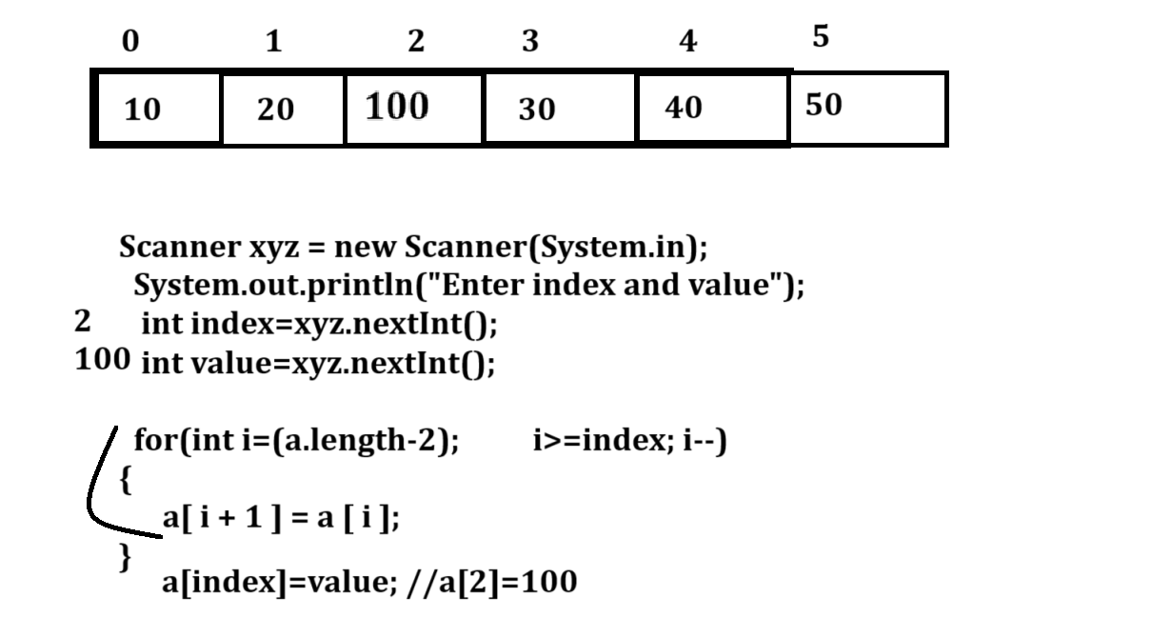

Two Dimensional Arrays
____________________________________________________________________________
Two Dimensional arrays is used for create the matrix but it is not matrix internally
It is way to create matrix by using programming.

How to declare two dimensional arrays in JAVA
_________________________________________________________________________
If we want to declare two dimensional arrays in java we have use following syntaxes
Syntax: datatype variablename[][];
or
datatype [][]variablename;
or
datatype []variablename[];
Example:
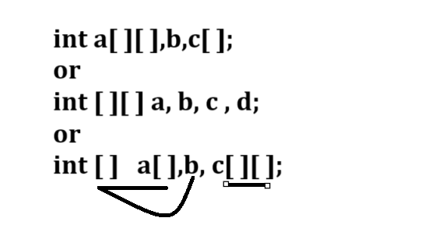
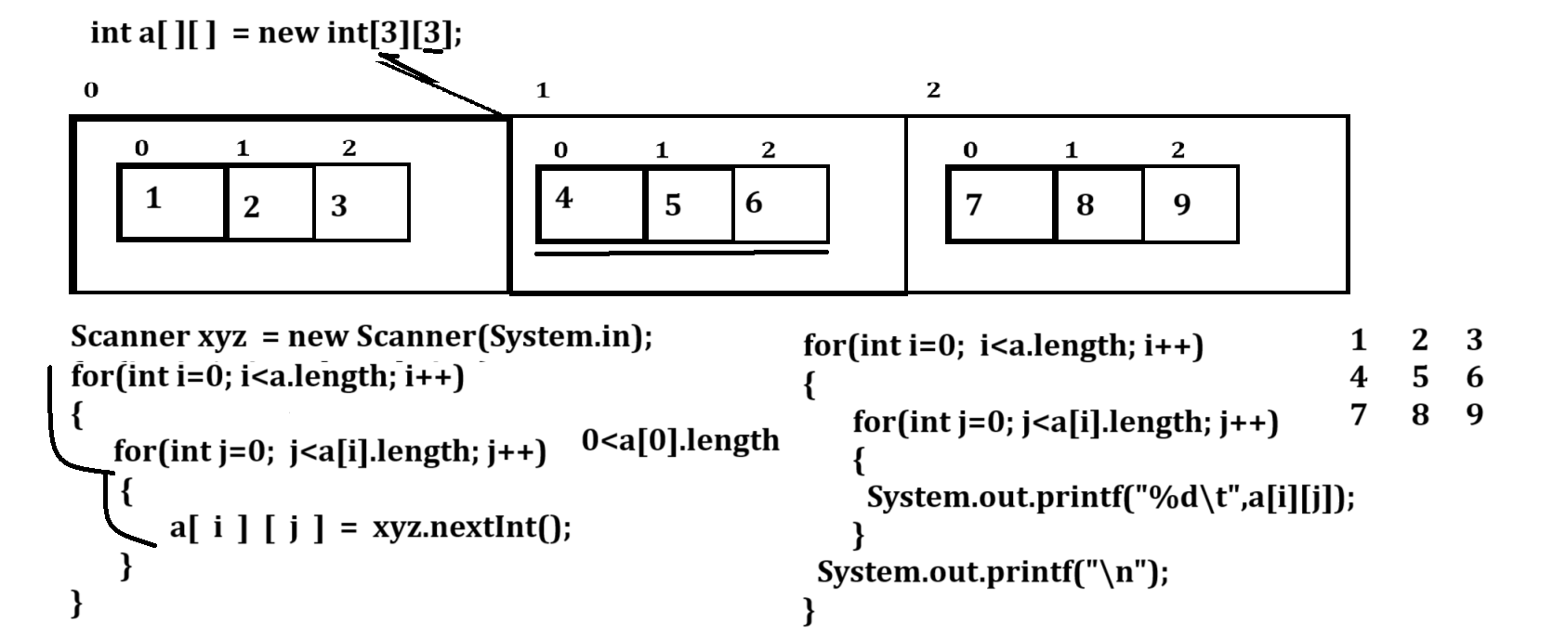

Example with source code
import java.util.*;
public class MatApp
{
public static void main(String x[])
{
Scanner xyz = new Scanner(System.in);
int a[][]=new int[3][3];
System.out.println("Enter values in matrix");
for(int i=0; i<a.length; i++)
{
for(int j=0; j<a[i].length; j++)
{
a[i][j]=xyz.nextInt();
}
}
System.out.println("Display matrix");
for(int i=0;i<a.length;i++)
{
for(int j=0;j<a[i].length; j++)
{ System.out.printf("%d\t",a[i][j]);
}
System.out.printf("\n");
}
}
}
Jagged Array
___________________________________________________________________
Jagged array is a concept where we can create matrix with every row having different column list.
1 2 3
4 5 6 7
8 9
Example
Syntax:
data type variablename[][] =new datatype[rowsize][];
variablename[rowindex]=new datatype[colsize];
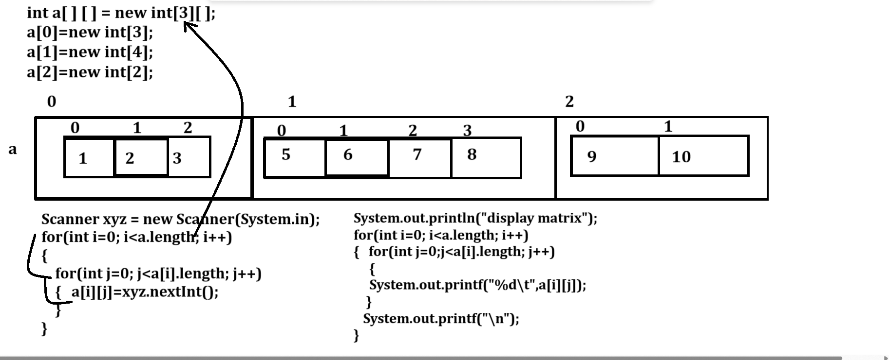
Example with source code
import java.util.*;
public class JaggedArrayApp
{
public static void main(String x[])
{ Scanner xyz = new Scanner(System.in);
int a[][]=new int[3][];
a[0]=new int[3];
a[1]=new int[4];
a[2]=new int[2];
System.out.println("Enter values in array");
for(int i=0; i<a.length;i++)
{
for(int j=0;j<a[i].length; j++)
{
a[i][j]=xyz.nextInt();
}
}
System.out.println("display the array values");
for(int i=0; i<a.length;i++)
{
for(int j=0;j<a[i].length;j++)
{ System.out.printf("%d\t",a[i][j]);
}
System.out.printf("\n");
}

}
}
Example: WAP to create function name as int [] getMergeArray(int a[],int b[])
you have to create two array of size 5 and merge them in third array and return merge from function

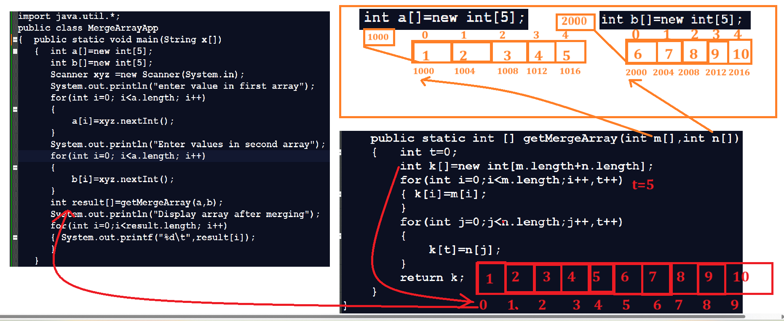
Merging Example with source for
import java.util.*;
public class MergeArrayApp
{ public static void main(String x[])
{ int a[]=new int[5];
int b[]=new int[5];
Scanner xyz =new Scanner(System.in);
System.out.println("enter value in first array");
for(int i=0; i<a.length; i++)
{
a[i]=xyz.nextInt();
}
System.out.println("Enter values in second array");
for(int i=0; i<a.length; i++)
{
b[i]=xyz.nextInt();
}
int result[]=getMergeArray(a,b);
System.out.println("Display array after merging");
for(int i=0;i<result.length; i++)
{ System.out.printf("%d\t",result[i]);
}
}
public static int [] getMergeArray(int m[],int n[])
{ int t=0;
int k[]=new int[m.length+n.length];
for(int i=0;i<m.length;i++,t++)
{ k[i]=m[i];
}
for(int j=0;j<n.length;j++,t++)
{
k[t]=n[j];
}
return k;
}
}

Example: WAP to create function name as boolean checkAnagram(int a[],int b[]) this function accept two array of size 5 and check arrays are anagram or not if array anagram return true otherwise return false.
Note: anagram means if two arrays contain same data but sequence is different called as anagram array.

Example with source code
import java.util.*;
public class CheckAnagramApp
{ public static void main(String x[])
{ int a[]=new int[5];
int b[]=new int[5];
Scanner xyz = new Scanner(System.in);
System.out.println("Enter first array");
for(int i=0;i<a.length; i++)
{ a[i]=xyz.nextInt();
}
System.out.println("Enter second array");
for(int i=0;i<b.length;i++)
{ b[i]=xyz.nextInt();
}
boolean result=checkAnagramArray(a,b);
if(result){
System.out.println("Array is anagram");
}
else{
System.out.println("Array is not anagram");
}
}
public static boolean checkAnagramArray(int m[],int n[])
{ boolean flag=true;
for(int i=0;i<m.length;i++)
{
for(int j=(i+1);j<m.length;j++)
{ if(m[i]>m[j])
{
int temp=m[i];
m[i]=m[j];
m[j]=temp;
}
if(n[i]>n[j])
{
int temp=n[i];
n[i]=n[j];
n[j]=temp;
}
}

}
for(int i=0;i<m.length;i++)
{
if(m[i]!=n[i])
{ flag=false;
break;
}
}
return flag;
}
}
Example: WAP to input character array and extract digit from it and calculate its sum and return it
Note: you have to create function name as int getDigitSum (char ch[])
Example: abc123mno456stv
Sum = 1+2+3+4+5+6 = 15
import java.util.*;
public class ExtractDigitSum
{ public static void main(String x[])
{ char ch[]=new char[10];
Scanner xyz = new Scanner(System.in);
System.out.println("Enter data in character array");
for(int i=0; i<ch.length; i++)
{ ch[i]=xyz.nextLine().charAt(0);
}
int sum=getDigitSum(ch);
System.out.println("Sum of digit is "+sum);
}
public static int getDigitSum(char ch[])
{ int s=0;
for(int i=0; i<ch.length;i++)
{ if(ch[i]>=48&& ch[i]<=57){
s= s+((int)ch[i]-48);
}
}
return s;
}
}

Example: WAP to create two character array adding letters in alternating order.
import java.util.*;
public class MergeAlternateApp
{
public static void main(String x[])
{ char first[]=new char[3];
char second[]=new char[3];
char result[]=new char[first.length+second.length];
Scanner xyz = new Scanner(System.in);
System.out.println("Enter values in first array");
for(int i=0; i<first.length;i++)
{ first[i]= xyz.nextLine().charAt(0);
}
System.out.println("Enter value in second array");
for(int j=0; j<second.length;j++)
{ second[j]=xyz.nextLine().charAt(0);
}
//we have add merging logics
for(int i=0,f=0,s=0;i<result.length;i++)
{
if(i%2==0)
{ result[i]=first[f];
f++;
}
else{
result[i]=second[s];
s++;
}
}
System.out.println("Display array values");
for(int i=0;i<result.length;i++)
{ System.out.printf("%c",result[i]);
}
}
}
Above program using integer array
import java.util.*;
public class MergeAlternateApp
{
public static void main(String x[])
{ int first[]=new int[3];
int second[]=new int[3];
int result[]=new int[first.length+second.length];
Scanner xyz = new Scanner(System.in);
System.out.println("Enter values in first array");
for(int i=0; i<first.length;i++)
{ first[i]= xyz.nextInt();
}
System.out.println("Enter value in second array");
for(int j=0; j<second.length;j++)
{ second[j]=xyz.nextInt();
}
//we have add merging logics
for(int i=0,f=0,s=0;i<result.length;i++)
{
if(i%2==0)
{ result[i]=first[f];
f++;
}
else{
result[i]=second[s];
s++;
}
}
System.out.println("Display array values");
for(int i=0;i<result.length;i++)
{ System.out.printf("%d\t",result[i]);
}
}
}

Example: WAP to given character array s check if it can be constructed by taking a substring of it and appearing multiple copies of the substring together.
Input: s= a b a b
Output: true
Example: it is the string ab twice

Input: s=a b a
Output: false

Input: abc abc abc abc
Here abc occur four times
Output: true

Example: WAP Move zeros
Given an integer array nums move all 0’s to the end of it while maintaining the relative order of non zero elements
Note: you have to do this in place without making a copy of the array.
Example: 0 1 0 3 12
Output: 1 3 12 0 0

import java.util.*;
public class MoveZero
{
public static void main(String x[])
{
Scanner xyz = new Scanner(System.in);
int a[]=new int[5];
System.out.println("enter data in array");
for(int i=0; i<a.length;i++)
{ a[i]=xyz.nextInt();
}
System.out.println("Before move zero");
for(int i=0;i<a.length;i++)
{ System.out.printf("%d\t",a[i]);
}
//logic of move zero
int left=0;
for(int i=0;i<a.length;i++)
{
if(a[i]!=0)
{
int temp=a[i];
a[i]=a[left];
a[left]=temp;
left++;
}
}
System.out.println("\nAfter move zero");
for(int i=0;i<a.length;i++)
{ System.out.printf("%d\t",a[i]);
}

}
}

